**DATA ANALYSIS ON ANDROID APPS ON GOOGLE PLAYS STORE**

**PREPARED BY**

**MADULEME VINICENCIA**

**31ST AUGUST, 2023**

**Overview**

Mobile applications are crucial in today's digital world since they provide solutions in many different industries. Platforms like Android Studio have made app development more accessible, luring both seasoned developers and newcomers with the promise of financial reward. This research examines categories, ratings, installations, and other factors while analyzing a dataset of more than 10,000 Google Play Store apps. It uses key performance indicators (KPIs) like user ratings and downloads to identify market trends and possibilities. This paper presents the findings of Vinicencia Maduleme's analysis of Google Play Store apps, which will be useful to both users and developers and advance the market.

**Methodology: Quantitative Analysis with Visualization**

This study used a quantitative analytical methodology, extracting data from an original Excel dataset that contained information about more than 10,000 mobile apps from the Google Play Store using SQL. To assure data reliability, extensive cleansing and structuring were required. Bar charts were employed to depict data visually, and SQL queries were created to retrieve important quantitative measurements and insights. This method allowed for a thorough examination of the dataset's trends and patterns, providing insightful data on user preferences, app performance, and market dynamics.

**Analysis**

"Through our investigation into the Android app market, we found several intriguing trends and findings. We used SQL queries to delve into significant indicators including user reviews, download totals, and app price. This assisted us in better comprehending user satisfaction and the most well-liked apps. In order to make it simpler to distinguish between different app genres and categories, we also employed bar charts to display these data. Our analytics show that some genres are more lucrative and more interesting than others. Even so, we discovered links between user reviews and the success of apps. These findings give us a clear understanding of how the Android app market operates, assisting both consumers and developers in choosing apps that are suitable for their needs.

**Result 1: Top 10 genres with the highest numbers of apps**

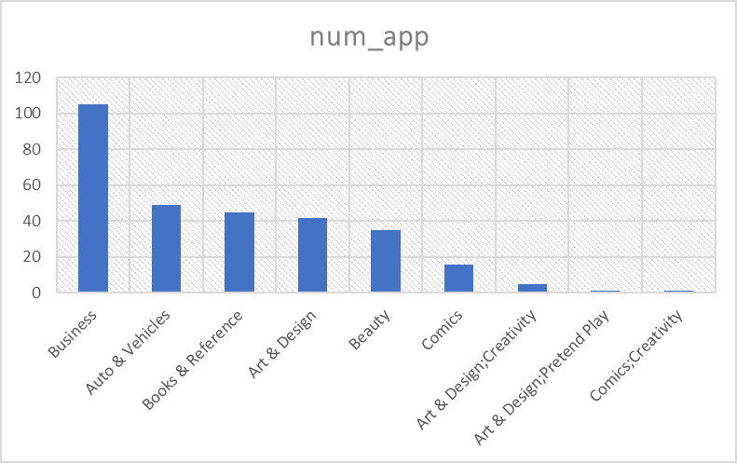

Business is the most popular genre on the Android app market, with 105 apps, followed by Auto & Vehicles (49), Books & Reference (45), Art & Design (42), Beauty (35), Comics (16), and unusual genres like Art & Design;Creativity and Comics;Creativity, each with just 1 app, demonstrating the wide variety that users and developers have access to.

**Result two: What percentage of apps are free and paid**

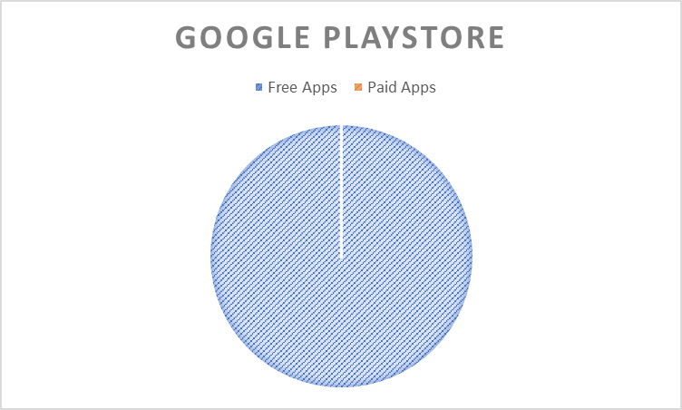

According to the results of the query, it appears that there are 299 apps in the dataset under analysis that are labeled as "Free," while there are none that are labeled as "Paid." Since none of the apps in the sample are priced, the analysis shows that all of them are free. It is critical to confirm the dataset's accuracy because this result implies a lack of paid apps, which could be unexpected depending on the source and thoroughness of the data.

**Result three: Top 5 category with the highest numbers of app**

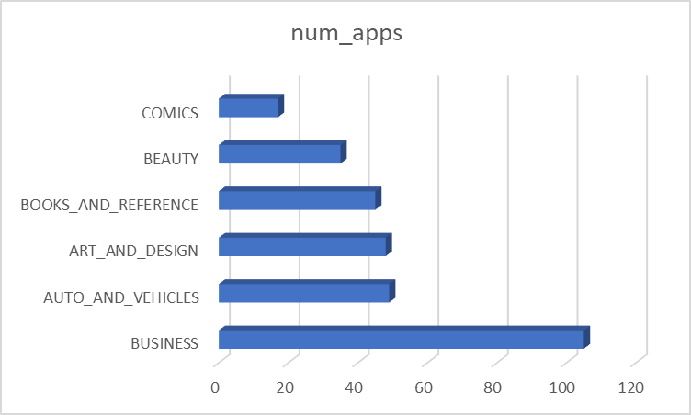

The top 5 app categories with the greatest number of apps are shown in this bar graph. The category 'Business' has the most apps (105), followed by 'Auto & Vehicles' (49), 'Art & Design' (48), 'Books & Reference' (45), and 'Beauty' (35). A clear visual depiction of the distribution of categories within the dataset is provided by each bar, which indicates the corresponding app count in these categories.

**Result Four: What is the app with the highest earning**

Listed under BOOKS_AND_REFERENCE, "Flybook" has a 3.9 rating based on 1,778 reviews. The 4.9MB application has been downloaded by over 500,000 individuals. It may be downloaded for free and has a content rating of Mature 17+. We have utilized the number of installs as a proxy for income due to its broad use and accessibility, as well as the fact that it is free, as more users typically equal to larger revenue opportunities. Our SQL query, which used "Flybook" as a representative example in our investigation, yielded this information.

**Result Five: What is the most expensive app in the store**

It is important to note that there is no direct measure of earnings available in the dataset because all of the apps in it are described as being free. It is difficult to identify the app with the biggest revenue without explicit pricing information or information on in-app purchases. The dataset mainly offers perceptions about the acceptance, user base, and features of the platform's free apps.

**Result Six: Top 10 most installed apps**

* Flybook - 500,000+ installs
* Coloring book moana - 500,000+ installs
* Only 30 days in English, the guideline is guaranteed - 500,000+ installs
* Offline: English to Tagalog Dictionary - 500,000+ installs
* English to Urdu Dictionary - 500,000+ installs
* Girls Hairstyles - 500,000+ installs
* NOOK App for NOOK Devices - 500,000+ installs
* Sticker Camera - Selfie Filters, Beauty Camera - 500,000+ installs
* Photo Designer - Write your name with shapes - 500,000+ installs
* Recipes of Prophetic Medicine for free - 500,000+ installs

**Result Seven: Top 10 categories with the highest number of installs**

The top 10 categories with the most installations are shown in "Result Six, illuminating the most popular app genres among consumers. Providing a larger view of user preferences inside the dataset, this insight expands upon the earlier discovery of the top 10 most installed apps. 'BOOKS_AND_REFERENCE,' 'FAMILY,' 'GAME,' and 'TOOLS' routinely top both app installations and counts, demonstrating a significant user preference for these genres. This in-depth analysis of user behaviour at the category level offers essential advice for app marketers and developers looking to succeed in the cutthroat Google Play Store market.

This concise summary of Result Seven highlights the importance of category-level data for marketers and developers.

**Conclusion**

"In brief, here's the lowdown if you're building an Android app: A popular category to choose from is "BOOKS_AND_REFERENCE," "FAMILY," "GAME," or "TOOLS." By providing them with the programs they enjoy, updating them frequently, and watching out for space usage, you can keep them satisfied. Additionally, make your app compatible with all Android versions since different Android versions are used by different users. You can succeed in the Google Play Store if you use these tips.